Charging of a Capacitor (data captured at 3 frames-per-second)
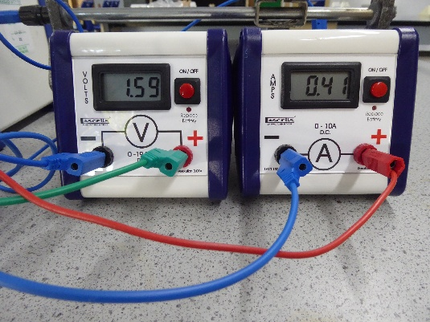 | 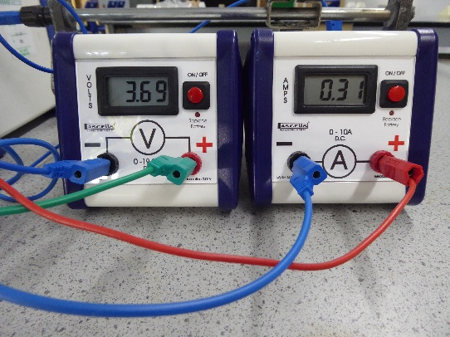 | 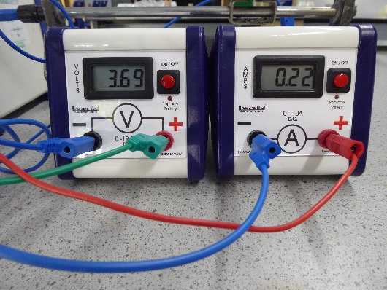
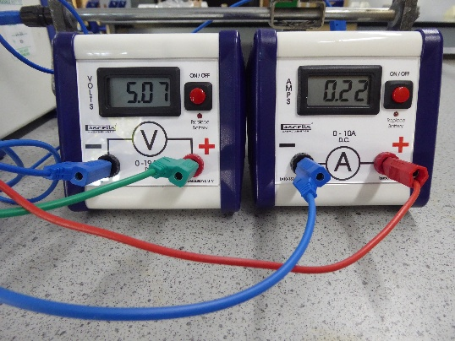 | 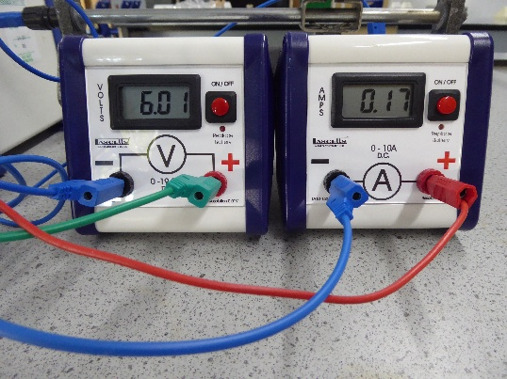 | 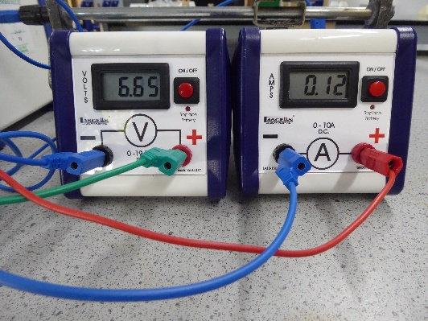
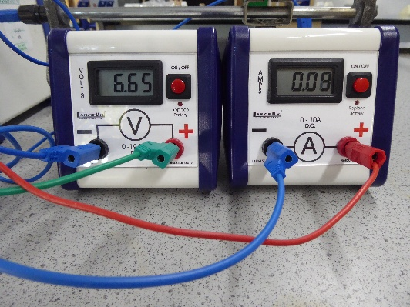 | 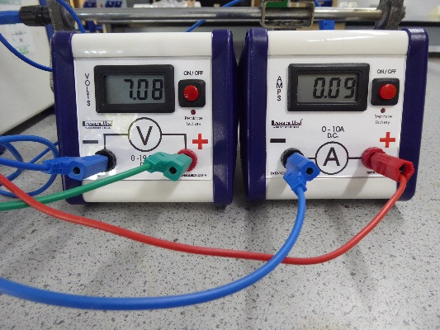 | 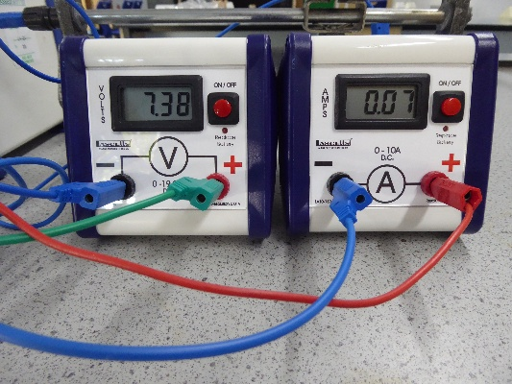
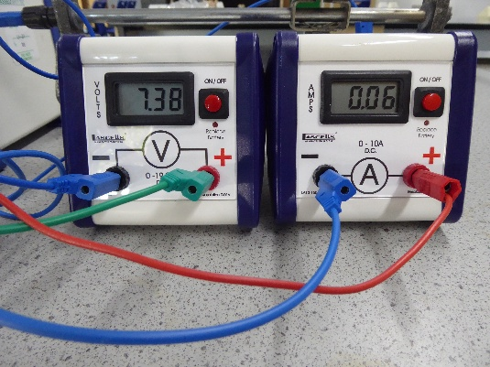 | 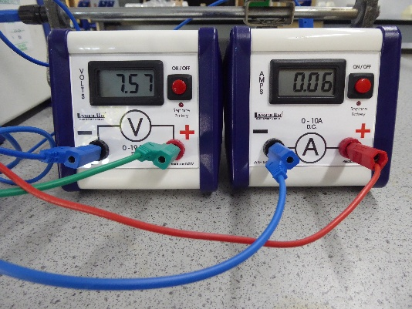 | 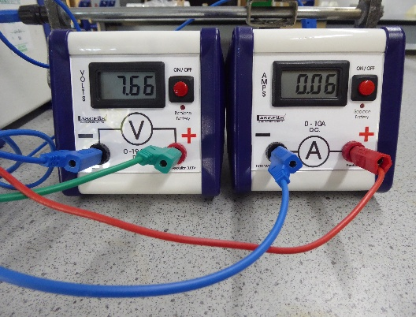
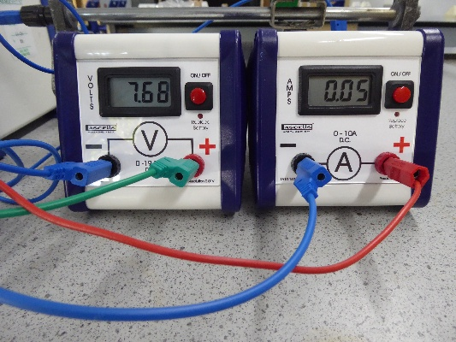 | 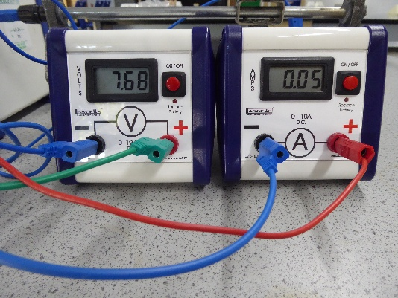 | 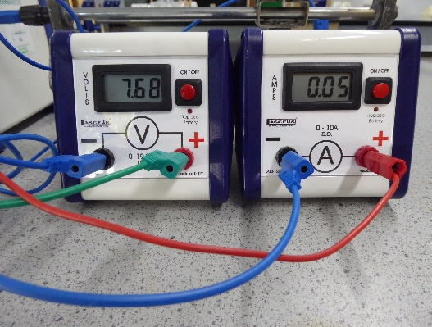

frame | 1 | 2 | 3 | 4 | 5 | 6 | 7 | 8 | 9 | 10 | 11 | 12 | 13 | 14
pd (V) | 1.59 | 3.69 | 3.69 | 5.07 | 6.01 | 6.65 | 6.65 | 7.08 | 7.38 | 7.38 | 7.57 | 7.66 | 7.68 | 7.68
current (A) | 0.41 | 0.31 | 0.22 | 0.22 | 0.17 | 0.12 | 0.08 | 0.09 | 0.07 | 0.06 | 0.06 | 0.06 | 0.05 | 0.05

