Ripple-tank experiment
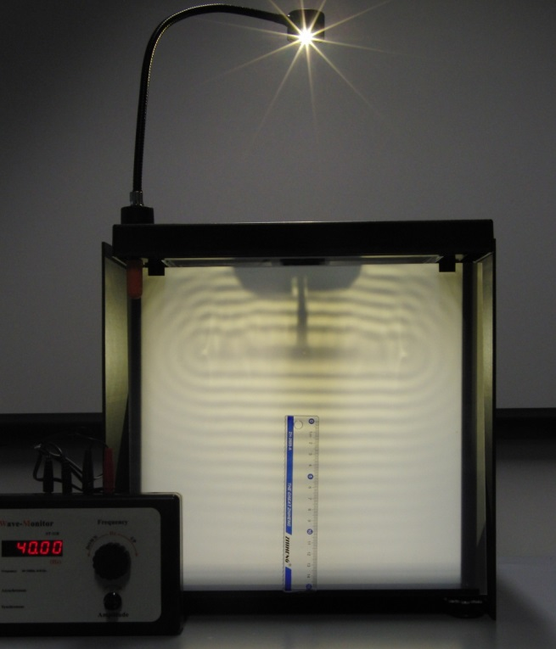 | 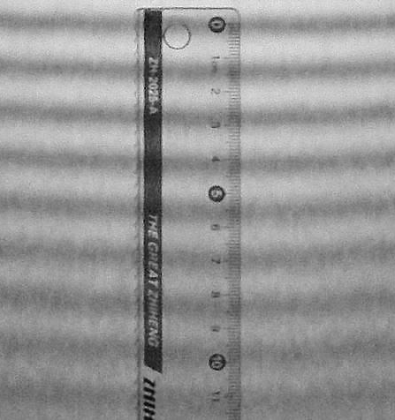
The apparatus (overall view) | Above: Wave pattern for 40 Hz
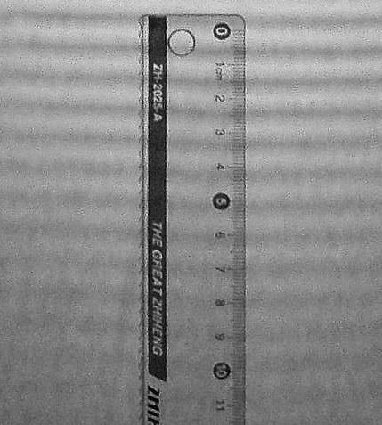 | 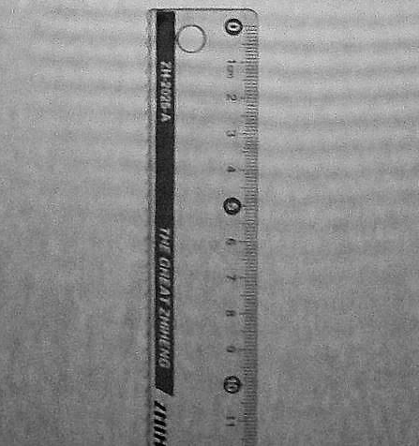
Above: Wave pattern for 70 Hz | Above: Wave pattern for 100 Hz

Your task is to use the three wave patterns shown here to calculate the mean speed of the water ripples.
The apparatus used is also shown (top left).
The wave crests (dark lines) are obviously much broader than the resolution of the measurement scale. You are therefore advised to print this sheet and to use a sharp pencil to identify the centres of the waves that you will use in your calculation for each frequency so you can make best use of the precision offered by the ruler. Remember that the lines you draw for the wave crests should be parallel to each other.
The wave speeds that you calculate must be given in metres-per-second (m/s).

